April 2018

CaMDiF Tool

User Manual



*Questions: ameri@txstate.edu*

Prepared By: Farhad Ameri and Reid Yoder

Texas state univerisy

This document provided detailed instructions on how to use the CaMDiF tool for creating instances of digital factory and analyzing the capabilities of the created factories.

# running the jar file

Download the executable jar file and double click on it to launch the program. The provided jar file runs on both Windows and Mac OS x. The launch screen of the tool provides the user with three options:

* **Build**: building a new digital factory or editing the existing factories
* **Analyze:** analyzing the manufacturing capabilities of digital factories
* **Match**: matching a work order with one or more digital factories that have the necessary capabilities to fulfill the order

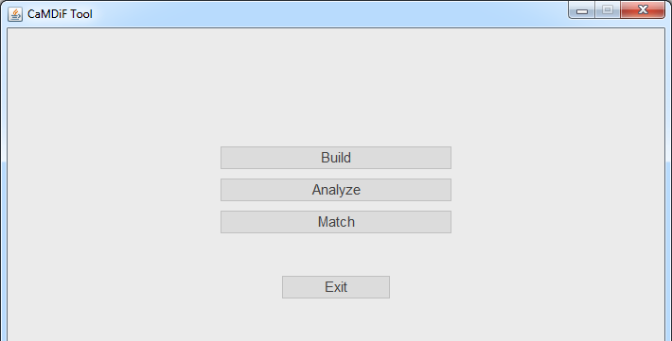

build

The build module provides the necessary functionality for creating user-made factories through adding various resources to the factory.

# create new factory

The first step for building a digital factory is to create a company that operates the factory.

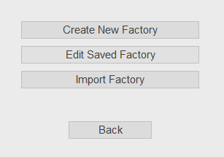

1. **Create New Factory:** Enter the requested information about the company that operates the factory. The fields with asterisk are required fields. Alternatively, you can edit a saved factory or import a factory (factory file with .owl extension).

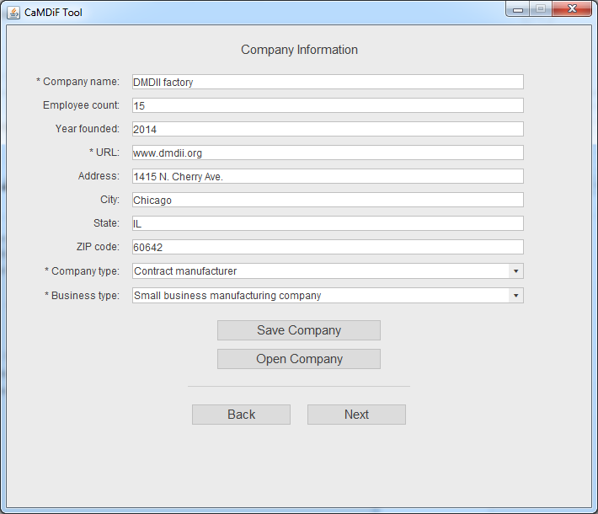

1. **Save Company:** Save the company after the necessary information is provided. The name of the company will be used as the name of the company file. Note that once the program is closed, the saved factories will be deleted.

**Open company:** Use this button to open a saved company within the current session.

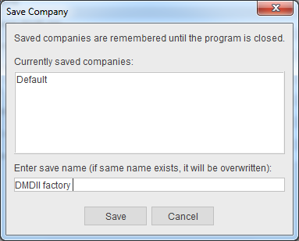

1. Press “Next” to go to the next step.

# adding machines to the factory

1. **Select Equipment:** Select Machine Tool from the “Select Equipment” dropdown menu.

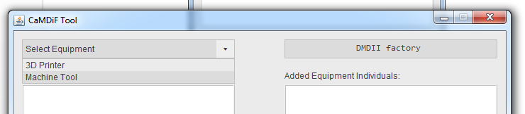

1. Select the type of equipment (for example Haas Vertical Mill) from the “Equipment Class” pane.
2. By selecting the equipment class, the lower pane is populated by specific equipment individuals from the selected class. Select the individual equipment you want to add to the factory and press the “>>” button.
   1. To delete equipment from the factory, select the equipment from the right pane and press “<<”.
   2. By clicking the “Info” button, the specifications of the selected equipment individual is shown in a popup screen.

|  |  |
| --- | --- |
|  |  |

1. To add 3D printers, select “3D Printer” from the dropdown menu and follow the procedure described in step 3 (above).

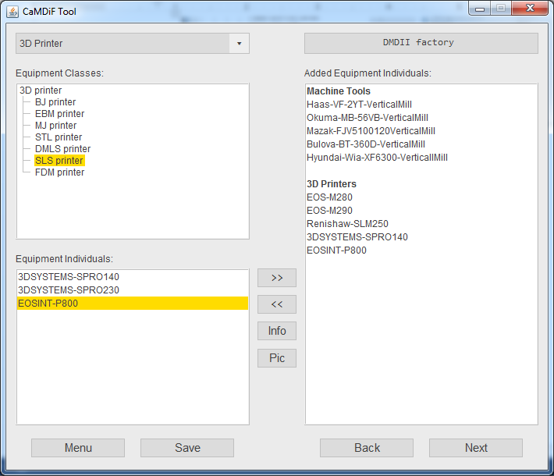

1. **Save:** Once all machines are added to the factory, save the factory.

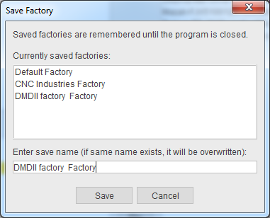

1. Press “Next” to go to the next step.

# adding other capabilities to the factory

In this step, other types of capabilities (including industry, material, skill, and software) can be added.

1. Select “Industry” from the dropdown menu.
   1. You will select the industries that the company typically serves.
2. Select the industry class from the top left pane.
3. Select the industry individual pertaining to the selected class from the bottom pane.
4. Press “>>” to add the selected industry individual to the factory (right pane).

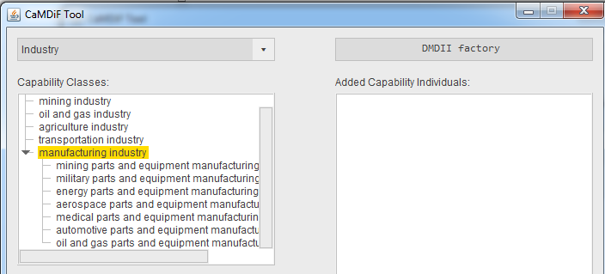

1. Repeat steps 2-4 for skill, material, and software.

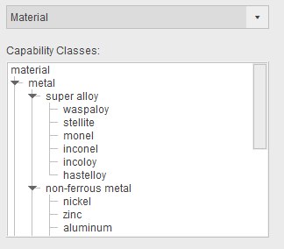

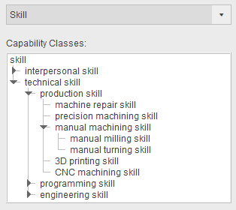

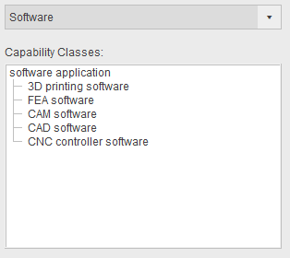

* 1. Note: When adding “skill” individuals, the level of skill (very low, low, medium, high, very high) should be given for each skill item.

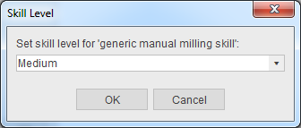

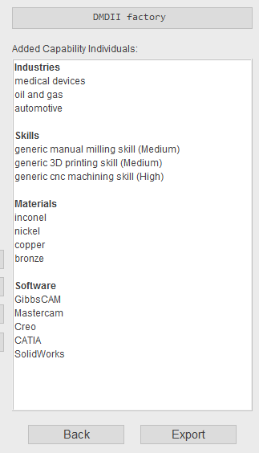

1. **Save.**
2. **Export:** Export the factory file as an RDF/XML file on your local computer. You can always import the exported file for further processing. But the saved files are only available in the current session.

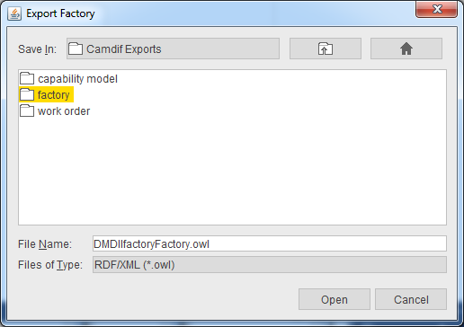

This is the end of the Build module. To analyze the created factory, click “Menu”.

analyze

The main function of this module is to interpret the manufacturing capabilities of the user-made factories. Using this module, either a single factory is analyzed individually or two factories are compared with each other.

# alalyze factory (one factory)

The analysis begins with selecting an existing (saved) factory or importing an external factory previously created using the CaMDiF tool.

1. Select Analyze from the launch screen.

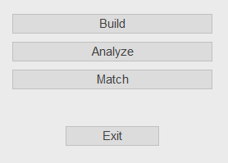

1. Select the factory you want to analyze.

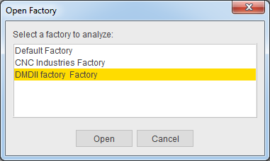

1. Part Quality Capability Tab: The first tab shows the capability of the factory with respect to the part attributes. If one or more cells in the “Explicit” column is empty, press “Infer Capability” to populate the inferred column.

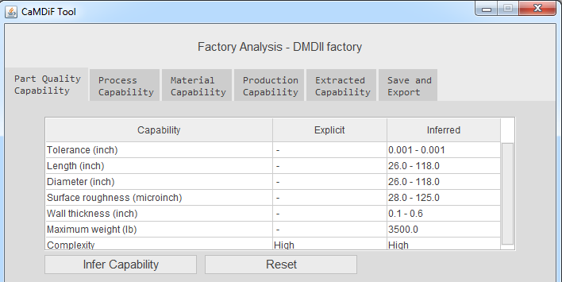

1. Process Capability Tab: This tab shows the types of manufacturing processes (explicit and implicit) available at the factory.

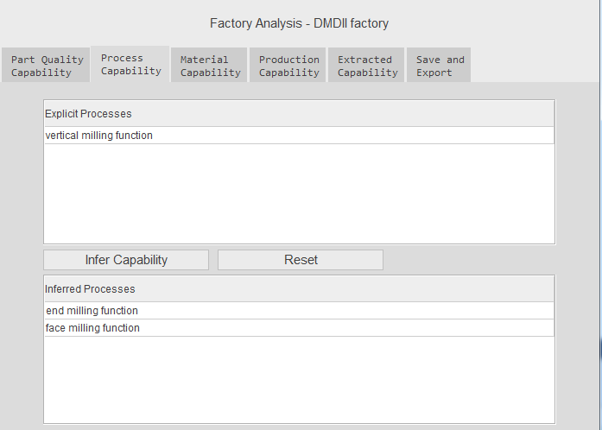

1. Material Capability Tab: This tab shows the list of materials that can be processed at the factory.

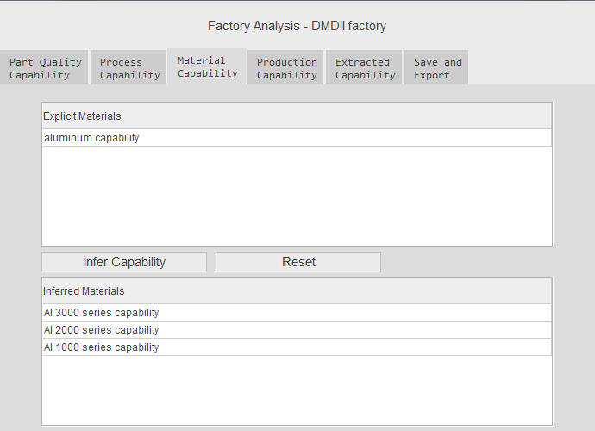

1. Production Capability Tab: This tab shows the production capability of the factory in terms of the variety of parts that can be manufactured, as well as production volumes.

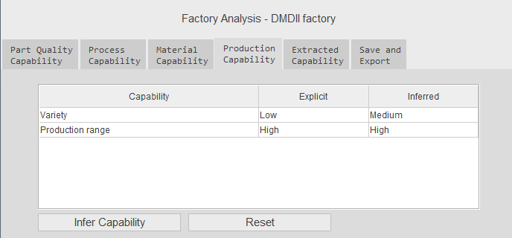

1. Extracted Capability Tab: This tab shows the keywords extracted from the website of the company categorized by different capability features. The number in the parenthesis next to a term shows the term’s (and its synonyms’) frequency of occurrence on the website’s pages.

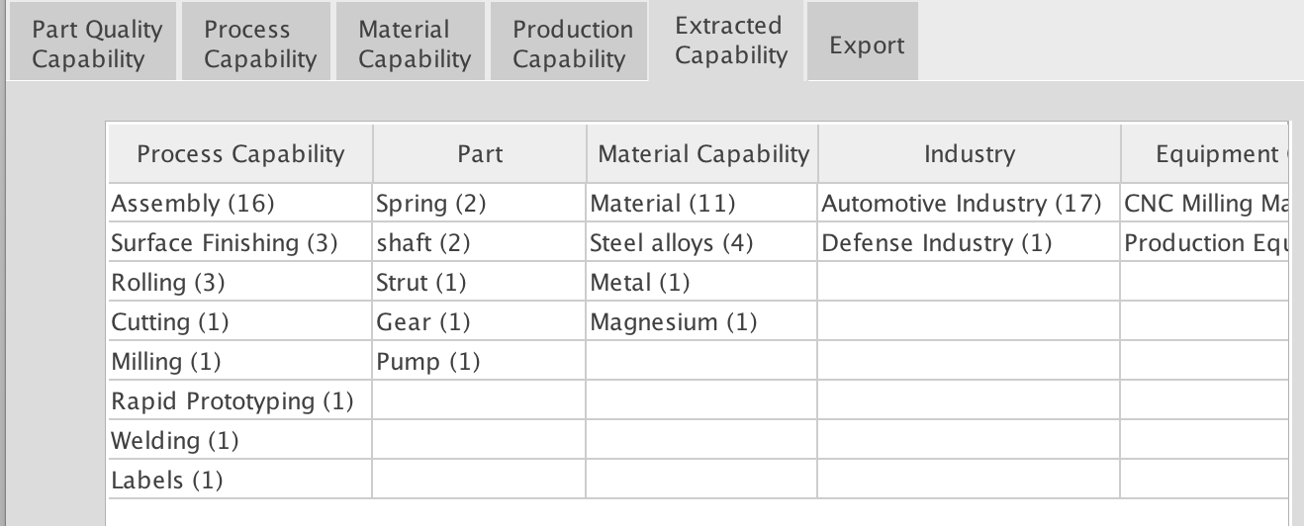

1. Save and Export: The capability file can be save and/or exported as an XML/RDF file. If the capability file is saved, then it is deleted once the session is closed. Exported files are saved permanently at a given location on the local drive. If “Include Factory File” is checked, then the capability model of the factory includes the factory file (machines, skills, software packages, etc) as well.

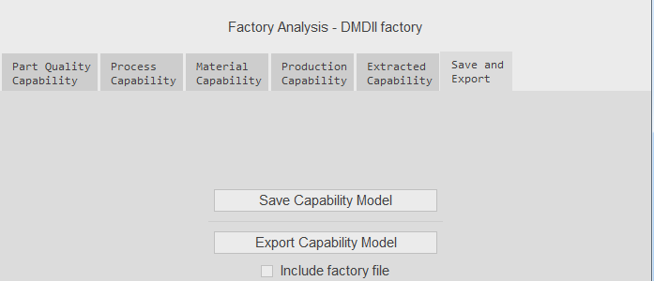

# compare factories

1. Press Compare Factories
2. Select the first factory to compare
3. Select the second factory to compare

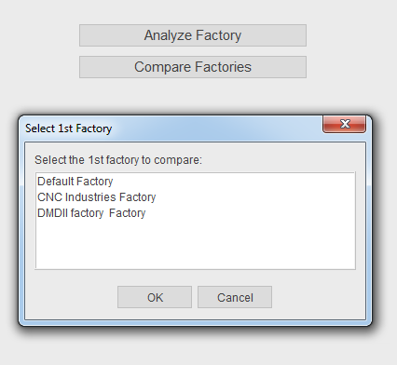

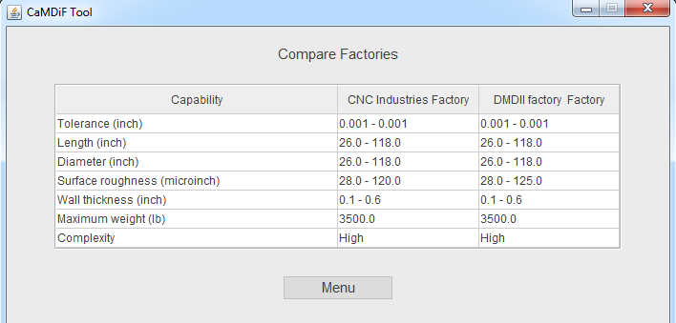

This is the end of the Analyze module. To run the Match module, click “Menu”.

Match

The match module is used for creating work orders and building supply chains that can manufacture the part described in the work order with the required quality and quantities.

# create new work order

1. Select **Create New Work Order.**
2. Enter the company information (similar to the first step in the build module). The company created at this stage is the issuer of the work order.
   1. Note: Alternatively, you can open a saved/imported work order and then edit it.
   2. All imported work orders are saved automatically.

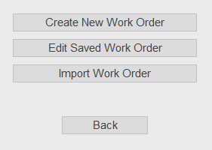

1. Enter the work order information (including part name, part materials, production volume, tolerances, dimensions, required processes, etc.).

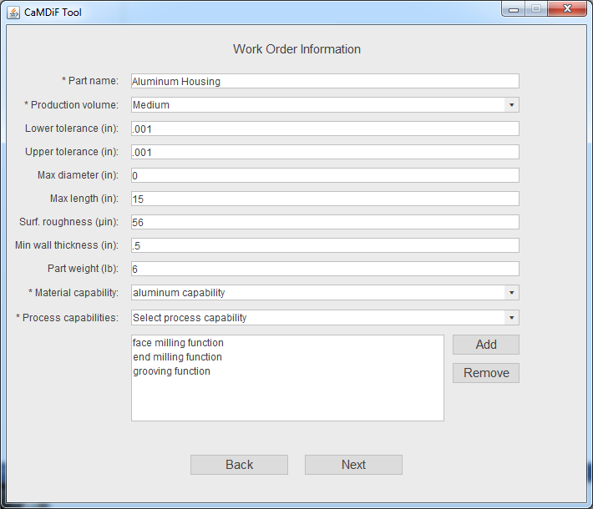

1. Add desirable capability features by browsing the tree structure.
   1. Here, *feature* refers to an aspect of capability represented by a term or phrase such as *turnkey service*, or *heavy part machining.*
   2. These features will be used in the next step to optimize the generated supply chains.

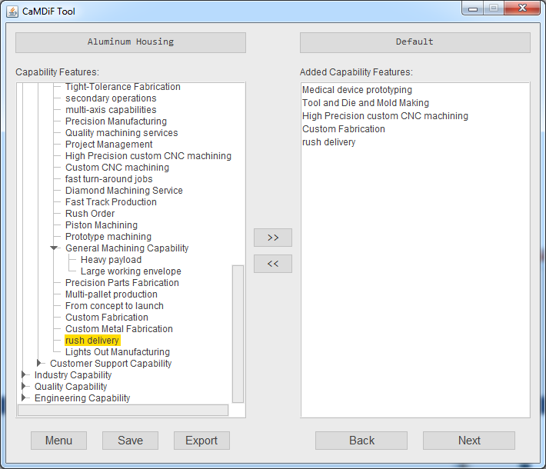

1. Save and/or export the work order.
2. Press “Next” to go to the next step (matching the work order with capability models of the saved factories)
3. If no capability model is saved in the “Analyze” step, an error message appears on the screen.

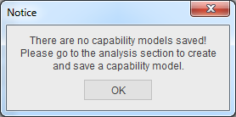

# Match work order with supply chains

1. Select the max allowable size of the desirable supply chain (1-4).
2. Select type of optimization method (feature-based or distance-based)
3. Click “Build Supply Chains”

